**The diffence between Int and Integer**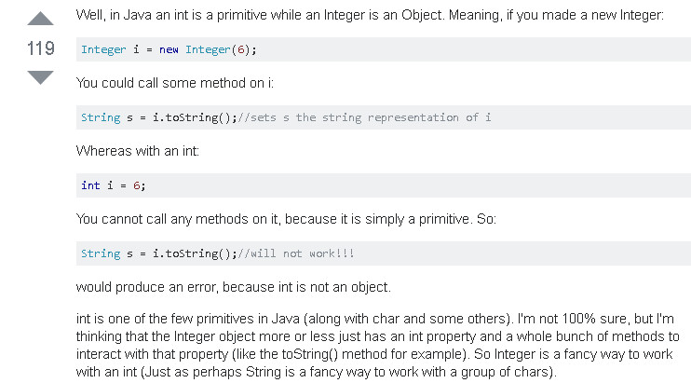

Primitive wrapper class

In object oriented programming, a **wrapper class** is a class that encapsulates types, so that those types can be used to create object instances and methods in another class that need those types. So a **primitive wrapper class** is a wrapper class that encapsulates, hides or *wraps* data types from the eight primitive data types, so that these can be used to create instantiated objects with methods in another class or in other classes. The primitive wrapper classes are found in the Java API.

Primitive wrapper classes are used to create an Object that needs to represent primitive types in Collection classes (i.e., in the Java API), in the java.utilpackage and in the java.lang.reflect reflection package. Collection classes are Java API defined classes that can store objects in a manner similar to how data structures like arrays store primitive data types like, **int**, **double**, **long** or **char**, etc. But arrays store primitive data types while collections actually store objects.

The difference between wrapper classes and primitive types

Primitive wrapper classes are not the same thing as are primitive types. The main difference is that whereas variables can be declared in Java as **double**, **short**, **int**, or **char**, etc., data types, the eight primitive wrapper classes create instantiated objects and methods that inherit but hide the eight primitive data types, not variables that are assigned data type values.

Therefore, the term *Primitive wrapper class* does not mean that wrapper classes are primitive types. It should be understood to be a class that wraps primitive types. Wrapper classes can be used to store the same value as of a primitive type variable but the instances/objects of wrapper classes themselves are *Non-Primitive*. We cannot say that Wrapper classes themselves are Primitive types. They just wrap the primitive types.

The Byte, Short, Integer, Long, Float, and Double wrapper classes are all subclasses of the Number class.

The wrapper classes BigDecimal and BigInteger are not one of the primitive wrapper classes but are immutable.

**Difference between an Array and a Collection**

